ETL Practical Task
Advanced Power BI – Data Engineering Simulation
Transformation Steps Documentation
Computer Science Department
2026
By
OWANI STUART 2300716991 23/U/16991/PS

1. Project Setup (Data Engineering Structure)
This section establishes the folder hierarchy and Power BI environment required for the ETL project.

1.1 Folder Structure
A dedicated desktop folder was created named: ETL Advanced [YourNames] [RegNo]. The following sub-folders were created inside to represent each ETL layer:
- 01 Raw Data – stores unmodified source files as received
- 02 Staging – holds intermediate, unprocessed query outputs
- 03 Processed – contains cleaned and transformed datasets
- 04 Output Reports – stores final Power BI reports and exports

1.2 Power BI Setup
- Opened Power BI Desktop and saved the workbook as: Advanced ETL Model.pbix
- Enabled Power Query Editor profiling tools:
- Column Quality – highlights valid, error, and empty cell percentages
- Column Distribution – shows unique and distinct value counts per column
- Error Detection – surfaces data type mismatches and transformation failures

2. Data Loading (Staging Layer)
Source data was loaded into Power Query without being pushed to the data model, keeping the staging layer separate from the model layer.

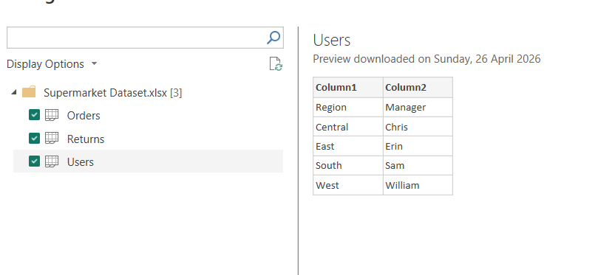
Figure 1 Figure showing staging process of loading data

2.1 Data Sources Loaded
- Supermarket Data (Excel/CSV format)
- Northwind Database (Microsoft Access .accdb format)

2.2 Staging Configuration
All loaded queries were configured with Load to: Connection Only to ensure no tables were pushed to the data model at this stage. Queries were renamed to standard staging conventions:

Staging Query Name | Source Table | Description
stg_orders | Sample Store Data | Raw order transactions
stg_customers | Northwind – Customers | Customer master records
stg_products | Northwind – Products | Product catalogue
stg_orderdetails | Northwind – Order Details | Line items per order
stg_users | Sample Store Data | User/manager records

3. Data Standardization Layer
This layer applies cleaning, renaming, and structural transformations to each staging query.

3.1 Managers Transformation (stg_users → dim_managers_stg)
- Renamed query from stg_users to dim_managers_stg
- Renamed columns for clarity:
Column1 → Region Code
Column2 → Manager FullName
- Split Manager FullName into two separate columns: First Name and Last Name (split by space delimiter)
- Created a Surrogate Key column using the following formula:
Manager Key = HASH(Region Code + Manager FullName)
This ensures a unique, system-generated identifier for each manager record.
- Applied text standardization:
- Trimmed leading and trailing spaces from all text columns
- Removed special characters using Clean transformation
- Standardized text casing (Title Case for names, UPPER for region codes)

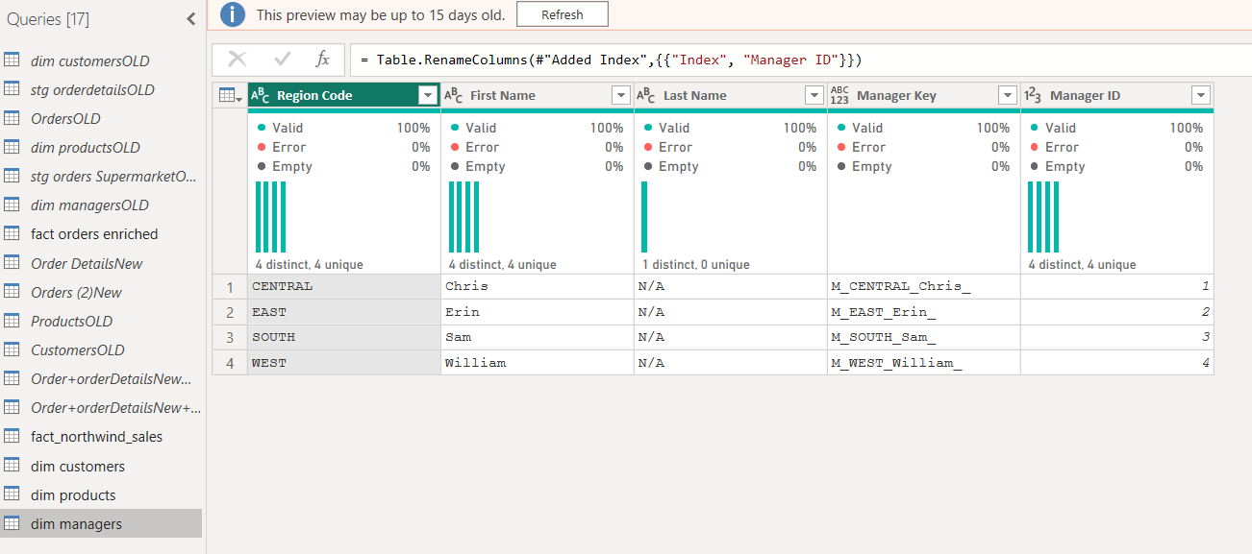
Figure 2 showing transformation of managers table

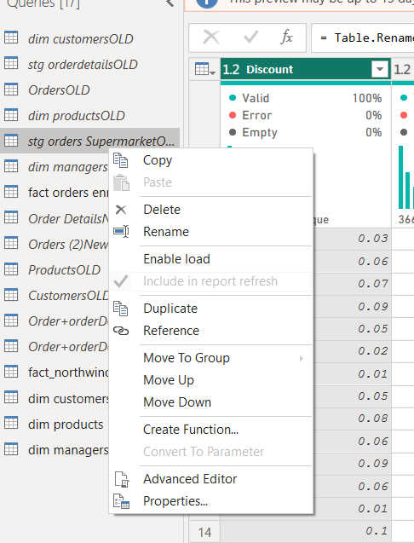
Figure 3 showing unticked Enable load to prevent it in appearing in data model

3.2 Orders Cleaning (stg_orders)
- Removed the following unnecessary columns to reduce data noise:
Row ID, Product Base Margin, Order Priority, Quantity Ordered New
- Filtered rows to include only the following five US states:
Arizona, California, Florida, New Jersey, New York
- Renamed columns for business-friendly naming:

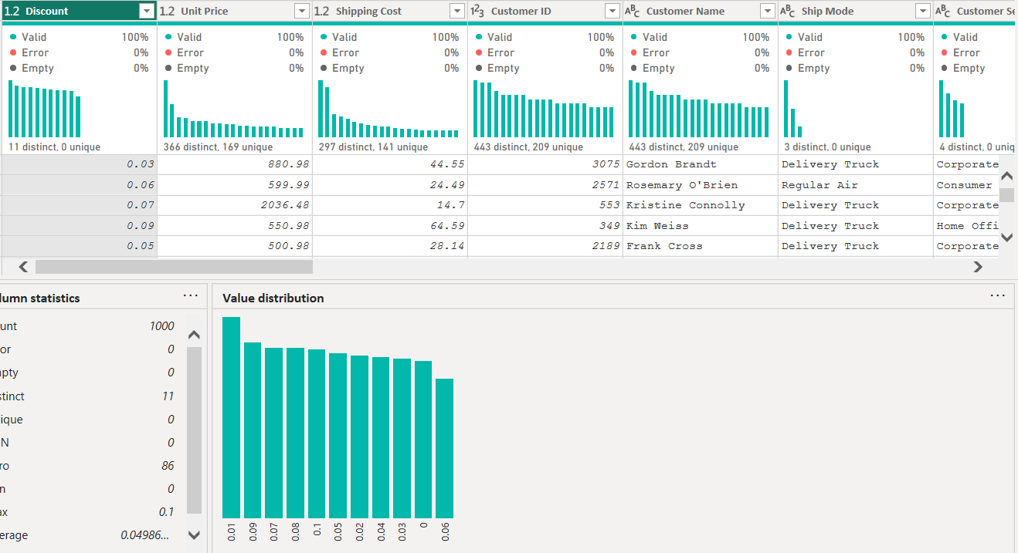
Figure 4 showing data quality
Original Column Name | Renamed To
State or Province | State
Postal Code | Zip Code
City | City Name

- Applied multi-column sort:
Primary Sort: State (Ascending)
Secondary Sort: Sales (Descending)

4. Data Integration Layer
Cleaned staging queries are merged in this layer to produce enriched fact tables.

4.1 Orders and Managers Join (fact_orders_enriched)
- Performed a Left Outer Join between stg_orders and dim_managers_stg on the Region Code column
- Expanded the following columns from the managers table after the join:
Manager Name, Region Code
- Created a conditional column: Manager Performance Class, based on Sales value:

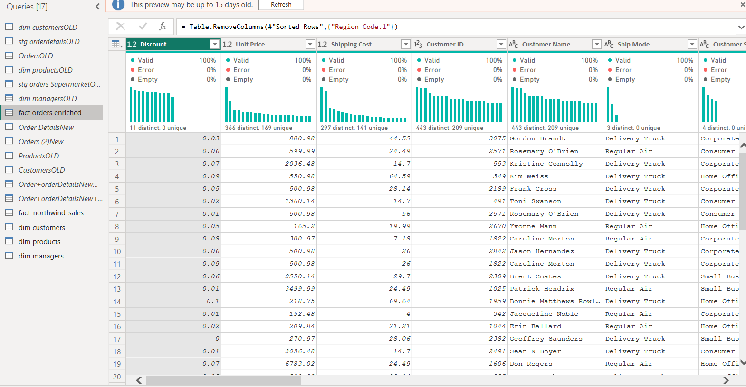
Figure 5 showing a fully created fact orders enriched table

Condition | Class Label
Sales > 10,000 | High
Sales between 5,000 and 10,000 | Medium
Sales < 5,000 | Low

- Filtered out all records where Region Code = 'Central'
- Applied sort by Manager Name (Ascending) then Sales (Descending)
- Saved and named the query: fact_orders_enriched

4.2 Northwind Integration (fact_northwind_sales)
- Performed a multi-step join across four Northwind tables:
Orders → Order Details (Join Key: OrderID)
Order Details → Products (Join Key: ProductID)
Orders → Customers (Join Key: CustomerID)
- Created three calculated measure columns:

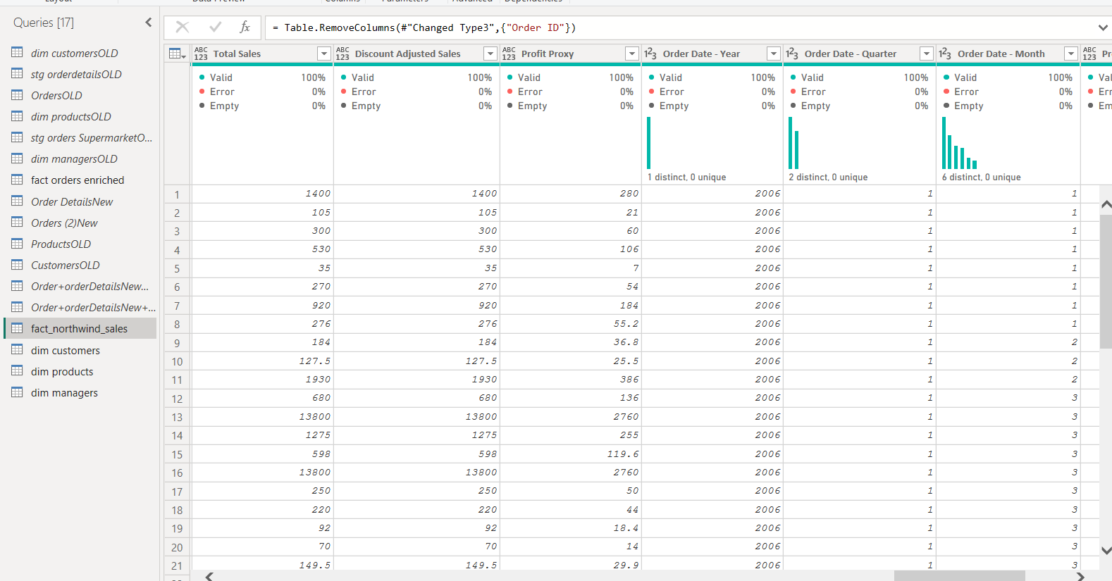
Figure 6 showing a fully created fact_northwind_sales table

Measure | Formula / Logic
Total Sales | Quantity × Unit Price
Discount Adjusted Sales | Total Sales × (1 – Discount)
Profit Proxy | Total Sales × 0.2

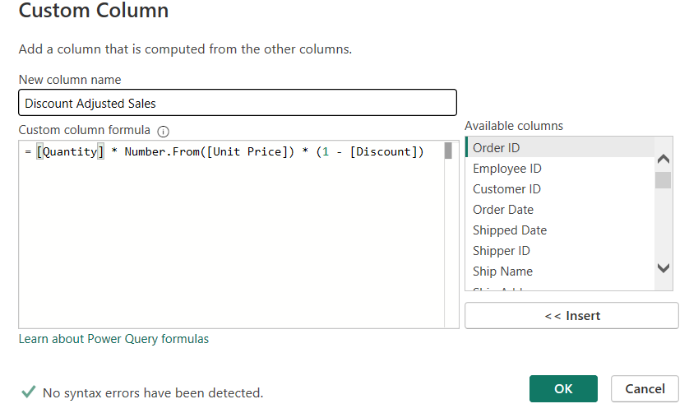
Figure 7 showing an example of how columns were created for the requested to be created
- Removed all NULL records and orphan rows (records without matching keys across joined tables)
- Saved and named the query: fact_northwind_sales

5. Business Logic Transformation
This layer applies formatting, date extraction, and data validation across both fact tables.

5.1 Formatting and Type Conversions
- Converted Discount column from decimal (e.g. 0.10) to whole number percentage (e.g. 10), with 0 decimal places
- Formatted Unit Price as USD currency (e.g. $12.50)

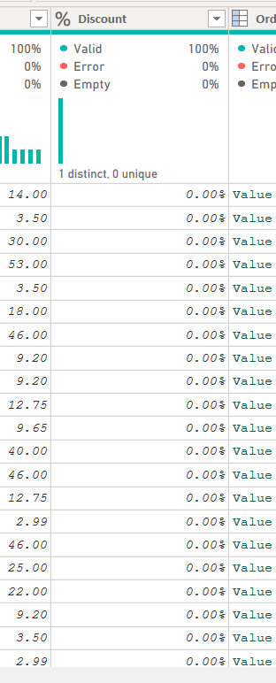
Figure 8 showing data format of Discount was changed to %

5.2 Date Decomposition
Extracted the following date components from the Order Date column:
- Year – numeric year extracted
- Quarter – Q1, Q2, Q3, or Q4 derived from month
- Month – month number (1–12) extracted
- Weekday Name column removed as it is not required for reporting
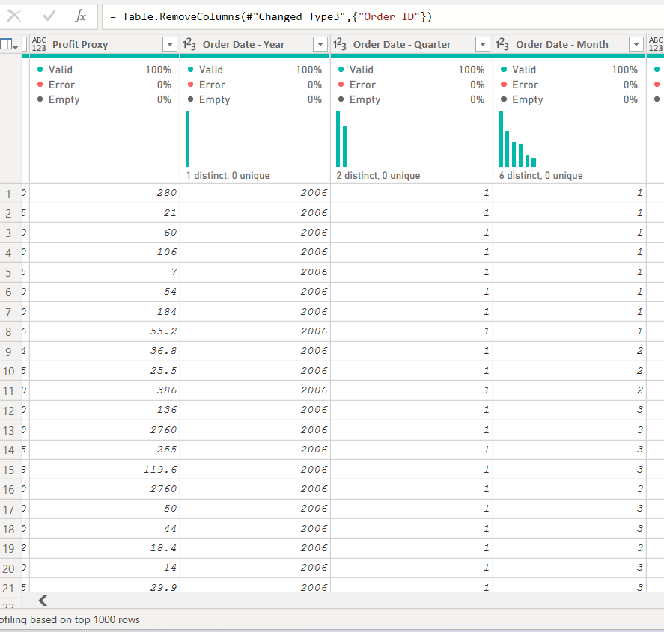
Figure 9 showing how columns were date columns for month,year and weekday that were created

5.3 Data Validation
- Verified no duplicate rows exist in either fact table
- Confirmed no NULL values appear in key columns (OrderID, CustomerID, ProductID, Manager Key)
- Validated all relationships reference correct and existing keys
- Ensured all columns have appropriate and consistent data types assigned

6. Advanced Analytics Preparation
Additional calculated columns were created to support dashboard-level analytics.

6.1 Customer Segmentation
A conditional column was added to classify customers based on their total Sales value:
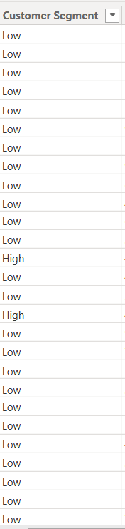
Figure 10 showing customer segment column

Sales Range | Segment Label
High Sales threshold | High
Mid-range Sales | Medium
Low Sales threshold | Low

6.2 Product Sales Ranking
A rank column was added to Products, ordering them by total Sales value in descending order. This allows identification of top-performing products at the dashboard layer.
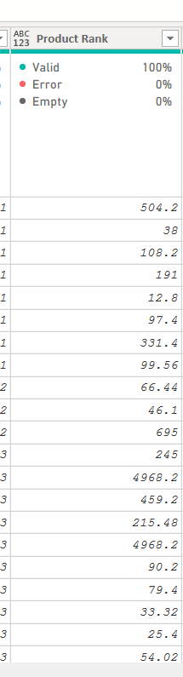
Figure 11 showing product rank column

6.3 Regional Performance Index
A composite index column was calculated using a weighted formula:
Regional Performance Index = (Sales × 0.5) + (Profit × 0.3) + (Discount Impact × 0.2)
This index enables comparison of regional contribution using a blended metric.

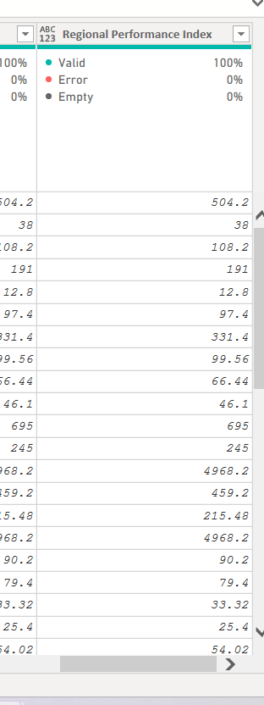

7. Final Data Warehouse Model
The final model is structured as a Star Schema, linking fact tables to dimension tables through surrogate keys.

7.1 Star Schema Structure
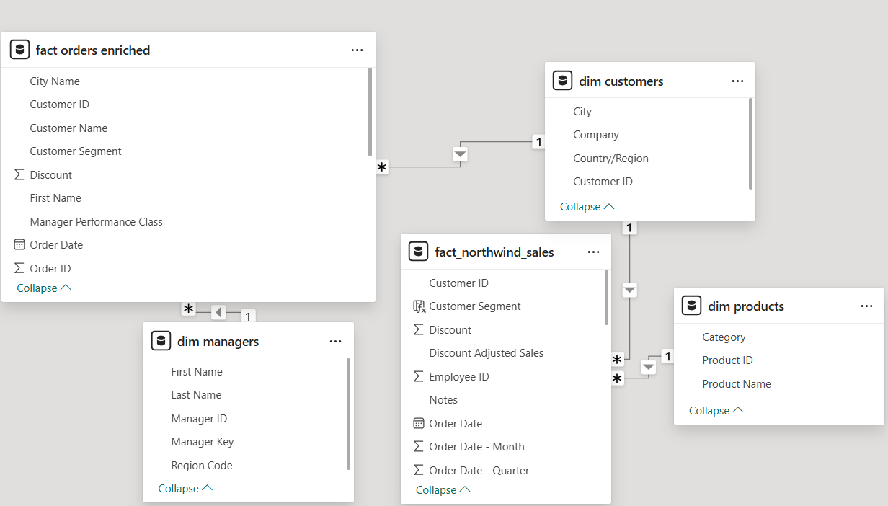
Figure 12 showing the star schema

Table Name | Type | Description
fact_orders_enriched | Fact | Enriched sales orders with manager performance data
fact_northwind_sales | Fact | Northwind transactional sales with calculated measures
dim_managers | Dimension | Manager master data with surrogate keys
dim_products | Dimension | Product catalogue from Northwind
dim_customers | Dimension | Customer master records from Northwind

7.2 Model Quality Rules Applied
- No redundant columns retained across tables
- Relationships established only on surrogate or primary keys
- All keys are clean, non-NULL, and uniquely identify each record
- No many-to-many relationships exist in the model

8. Validation Tasks
A final validation sweep was performed across all fact and dimension tables before the dataset was released for dashboard design.

8.1 Validation Checklist

Validation Check | Status | Notes
No duplicate primary keys | Pass | Verified using Column Distribution in Power Query
No NULL values in fact tables | Pass | Error Detection enabled; nulls removed in step 4.2
Referential integrity maintained | Pass | All foreign keys match existing dimension keys
Correct data types assigned | Pass | Dates, numbers, text verified per column
No orphan records | Pass | Removed during Northwind join step
Weekday names removed | Pass | Column dropped post date extraction
Central region excluded | Pass | Filter applied in fact_orders_enriched

8.2 Documentation Completion
All transformation steps, from raw data ingestion through to the final validated data warehouse model, were documented in this report. The dataset was ready for Power BI dashboard design, including:
- Creation of calculated measures using DAX
- Design of interactive visuals (charts, slicers, maps)
- Publication and sharing via Power BI Service

End of Transformation Documentation

